**Applied Physics**

**Assignment 02**

**Note:** Provide the detailed calculations with all steps. Submission due date **March 26, 2025**.

**Q 1**: Consider a ring of radius **R**, with uniform distribution of negative charge **Q**. Calculate the electric field due to ring at a distance ***d*** on the *x*-axis, the ring is placed in the *yz* plane.

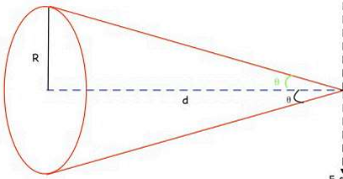

**Q 2**: Calculate the electric field due to a disk of charge at a point P, shown in Figure below. Suppose the disk is negatively charged with uniform charge distribution and having radius R.

